Winter Student Enrichment Packet
Social Studies



9th and 11th Grade

™

Prince George’s County Public Schools
Office of Academic Programs
Department of Curriculum and Instruction

NOTES FOR STUDENTS

Use and implementation of the activities contained in the Winter Student Enrichment Packet are optional and voluntary. The activities were selected to allow students to experience some fun with social studies over the Winter Break while simultaneously supporting practice with skills they will need to demonstrate on assessments near the end of the school year.

DIRECTIONS

What’s that bar code?


A QR code is a unique bar code that lets you instantly visit a web page from your smartphone or tablet.

Make sure your smartphone or tablet can scan a QR code with its camera, either with an application that you download or via software that’s already installed on your phone.

Search for FREE QR Reader Apps for your smartphone or tablet in your app store.

When you see a QR code, use your smartphone or tablet’s application to scan it and access the website.

INTRODUCTORY ACTIVITY

Guiding Inquiry: Why does historical thinking matter?

TASK ONE: Explore this interactive presentation at http://historicalthinkingmatters.org/why.html where Professor Sam Wineburg discusses how historians investigate what happened in the past.



TASK TWO: CONDUCT A HISTORICAL INVESTIGATION

Grade 9: The Scopes Trial
Analyze the influence that Hollywood, the Harlem Renaissance, the Fundamentalist Movements, and Prohibition had in changing American society in the 1920s.

Guiding Inquiry: How was the Scopes trial more complicated than a simple debate between evolutionists and creationists?
http://historicalthinkingmatters.org/students/scopestrial/



Grade 11: The Spanish-American War
Examine the causes, course, and consequences of the Spanish-American War.

Guiding Inquiry: Why did the United States invade Cuba?
http://historicalthinkingmatters.org/students/spanishamericanwar/



- INVESTIGATE: You will watch a short movie that introduces a question of historical debate.
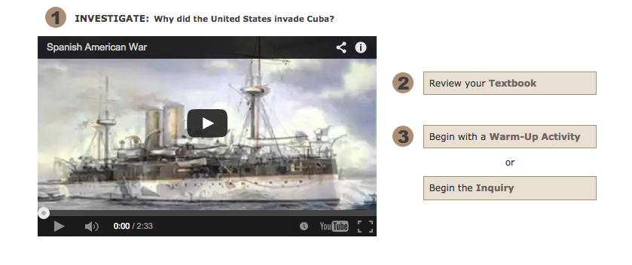
2. RESEARCH: Read each source, and then answer the questions in “The Notebook” http://historicalthinkingmatters.org/how/
Attached Resource: I READ Organizer

- WRITE: Once you have analyzed the sources, you will have the chance to bring all of your insights together by writing an essay that responds to the investigative question.
Attached Resource: How to Write Your Essay Organizer

Source: The “Historical Thinking Matters” lesson activities were taken in their entirety from http://historicalthinkingmatters.org and administered by George Mason University.
