Social Studies
Winter Student Enrichment Booklet


7th GRADE

™

Prince George’s County Public Schools
Office of Academic Programs
Department of Curriculum and Instruction

NOTES FOR STUDENTS AND PARENTS

Use and implementation of the activities contained in the Winter Student Enrichment Packet are optional and voluntary. The activities were selected to allow students to experience some fun with social studies over the Winter Break while simultaneously supporting practice with skills they will need to demonstrate on assessments near the end of the school year.

DIRECTIONS

What’s that bar code?


A QR code is a unique bar code that lets you instantly visit a web page from your smartphone or tablet.

Make sure your smartphone or tablet can scan a QR code with its camera, either with an application that you download or via software that's already installed on your phone.

Search for FREE QR Reader Apps for your smartphone or tablet in your app store.

When you see a QR code, use your smartphone or tablet’s application to scan it and access the website.

TASK ONE: CONDUCT A HISTORICAL INVESTIGATION
1. Log onto Think Port using the web address below or scan the QR code. http://ancientrivervalleys.thinkport.org/#home.html

2. Begin the historical investigation
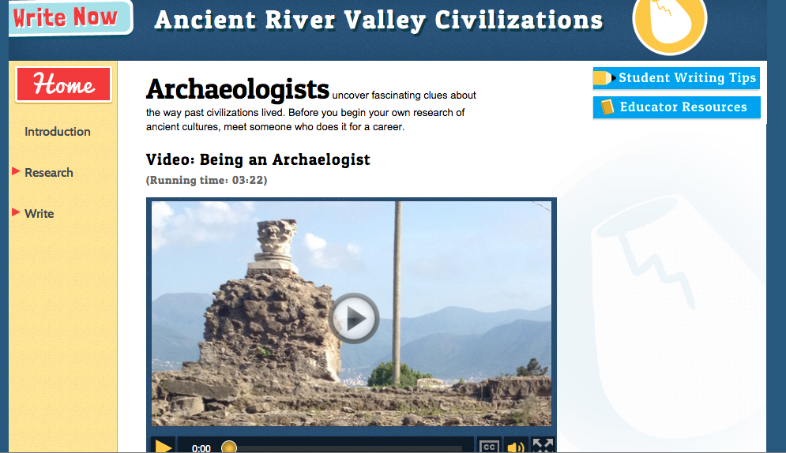
Introduction: Thinking like an archaeologist.

Research: Select artifacts and analyze primary and secondary sources.
Write an informative brochure article about the Ancient River Valley Civilizations.

Thinking Like An Archaeologist:
- Review images that represent artifacts and complete the Looking at Ancient River Valley Civilizations handout embedded in the activity.
Research:
- Research and take notes from primary and secondary sources. Collect the images you want to describe in your article and answer a list of related questions in the activity.
- Use the Writing for a Brochure on Ancient River Valley Civilizations handout to help gather bibliography information and research important cultural elements.
Write:
- Write a rough draft and place the selected images within your rough draft.
- Write final assignment.

Looking at Ancient River Valley Civilizations
Directions: Record information you could use in writing your article. Be sure to record the source where you found the information.

Example Source Citation:
Name the author of the article. Date of article, starting with the year. Title of page. Website name. Retrieved [insert date, including year] from [insert website URL].
Example: Pear, R. (2001, January 23). Gains reported for children of welfare to work families.
The New York Times on the Web. Retrieved January 23, 2001, from
http://www.nytimes.com/2001/01/23/us/gains-reported-for-children-of-welfare-to-work-families.html.
Ancient River Valley Civilizations
Cultural Element | Mesopotamia | Egypt | Harappa and Mohenjo-Daro | Huang He (Shang and Zhou)
Geography

Source of Information

Government

Source of Information
Social Structure

Source of Information
Religion

Source of Information
Achievements
Source of Information
Economic System

Writing A Brochure
Directions: Jot down your responses to these questions to help you organize what you want to say in your brochure.

What item are you writing about? What civilization did the object come from?

What are the years in which the civilization existed? When was the object created? When was it found?

Where was the object created? Where was the object found? What is that part of the world like?

Why is this object important to this civilization? What does it tell you about their values, beliefs, or ways of living?

