Government H.S.A.
Winter Student Enrichment Packet

10th Grade
Local, State, and National
Government

™

Prince George’s County Public Schools
Office of Academic Programs
Department of Curriculum and Instruction

NOTES FOR STUDENTS

General Directions

- Write your responses in this packet.
- Read each item carefully so that you can do your best when answering the Selected Response questions (SRs) and Constructed Responses (CRs).
- For SRs, circle the answer that is your choice.
- Provide a rationale for choosing your selected answer in the space provided.
- For the CRs, use the response box provided. Be sure to answer all parts of the question completely and provide appropriate details and examples. Included are two Dinah Zike Foldable activities to use as study aids. Complete each task using the directions and the United States Government: Democracy in Action textbook. These activities were adapted from the Dinah Zike United States Government Reading and Study Skills book included with the Textbook program.
- You will see arrows at the bottom-right corner of some pages. This tells you that the task continues onto the next page.

Helpful Hints

- This packet for the Winter Break has been created to provide practice for you to work through selected response and brief constructed response items related to previously learned concepts in Local, State, and National Government.

- The Winter Student Enrichment Packet contains selected and brief constructed response items (SRs and CRs), graphs, and charts.

- Please write your response to the SRs and CRs on the space provided in this packet.

SKILLS AND AREAS ASSESSED BY THE GOVERNMENT H.S.A.

Several skill areas are needed to successfully complete the Government H.S.A. Students must be able to understand and interpret such items as:

Charts
Graphs
Maps
Current Events
Primary Sources
Political Cartoons

Students will also be expected to recall key information, use problem-solving skills, and analyze issues.

AREAS TESTED BY THE GOVERNMENT H.S.A.
Core Learning Goal 1 | Political Systems
The student will demonstrate an understanding of the historical development and current status of principles, institutions, and processes of political systems.
Core Learning Goal 2 | Peoples Of The Nation And World
The student will demonstrate an understanding of the history, diversity, and commonality of the peoples of the nation and world, the reality of human interdependence, and the need for global cooperation, through a perspective that is both historical and multicultural.
Core Learning Goal 3 | Geography
The student will demonstrate an understanding of geographic concepts and processes to examine the role of culture, technology, and the environment in the location and distribution of human activities throughout history.
Core Learning Goal 4 | Economics
The student will demonstrate an understanding of the historical development and current status of economic principles, institutions, and processes needed to be effective citizens, consumers, and workers.
Note the changes

STUDENT RESPONSES AND THE SOCIAL STUDIES RUBRIC
Writing is a performance activity that allows students to reflect and elaborate on how they think and what they know. It is important to extend understanding of the expectations of the rubric with repeated opportunities to write 5-7 minute Constructed Responses. The Social Studies Rubric is used with every writing assignment. Writing has been reinstated on the Government H.S.A.!
Answers that include specific details and historical or contemporary applications demonstrate “powerful and insightful” responses and help students to recognize viewpoints and make inferences on what they have read. Exemplars for CR items can be found on www.mdk12.org.

The rubric on the next page includes “observations” to assist students in better understanding each level. Please carefully note the differences between a Level 4 and Level 3 answer—go for the 4!

Selected Response Questions

DIRECTIONS: Read each question carefully. Circle the correct answer.

- The Fifth Amendment protects many rights. It also defines the power of the government to take private property for public use. This power or right is called:
A Concurrent powers
B Revitalization
C Rule of law
D Eminent domain (This is the correct answer.)

Reflection: Justify why you chose your answer:
A- It could not be concurrent powers because the question did not ask anything about levels of government having the same power (taxing). B- Revitalization is when a neighborhood is being built up to better the community/economy and C- talks about rule of law, when government must follow the same rules/laws as citizens do. D- Eminent Domain is the correct answer because it is listed in the 5th Amendment as a right to citizens having “just compensation” for land if it is taken by government. Definition of eminent domain: The power of government to take private property for public use. (This term is also an assessment limit- one of those words I need to know to pass the HSA)

- In which form of government do sovereign states have more power than the central government?
- Federal
- Confederate
- Authoritarian
J Unitary

Reflection: Justify why you chose your answer _____________________________________
__________________________________________________________________________
__________________________________________________________________________

- Which of these is an economic goal of United States government policy?
A To limit competition
B To create a classless society
C To promote full employment
D To own the means of production

Reflection: Justify why you chose your answer _____________________________________
__________________________________________________________________________
__________________________________________________________________________
- “We the People…” as stated in the preamble of the Constitution states that our constitution is based on rule of the people. Identify the principle of government in which the preamble is supported.
F Popular sovereignty
G Rule by law
H Limited government
J Articles of Confederation

Reflection: Justify why you chose your answer _____________________________________
__________________________________________________________________________
__________________________________________________________________________

- Identify the system of government that divides power between the Federal government and State government:
- Communism
- Constitutionalism
- Republicanism
- Federalism

Reflection: Justify why you chose your answer _____________________________________
__________________________________________________________________________
__________________________________________________________________________

- The Fourth Amendment protects citizens from unreasonable search and seizure, this is an example of:
- Delegated power
- Judicial review
- General welfare
J Limited government

Reflection: Justify why you chose your answer _____________________________________
__________________________________________________________________________
__________________________________________________________________________

- Changes to the Constitution allow the document to reflect how our nation transforms over time. These changes are called:
- Amendments
- Clauses
- Laws
- Articles

Reflection: Justify why you chose your answer _____________________________________
__________________________________________________________________________
__________________________________________________________________________

- Which of these best describes the main purpose of an interest group?
- To influence government officials on specific issues
- To form legislative committees that study public policy
- To regulate the economy by setting federal lending rates
J To select cases for hearing in appeals courts

Reflection: Justify why you chose your answer _____________________________________
__________________________________________________________________________
__________________________________________________________________________

- Which of these would be an opportunity cost to a government offering a tax break to businesses that invest in new machinery?
A An increase in industrial innovation
B An increase in industrial productivity
C A decrease in the quality of goods exported
D A decrease in the amount of money collected

Reflection: Justify why you chose your answer _____________________________________
__________________________________________________________________________
__________________________________________________________________________

10. Which of these identifies a major weakness of the national government under the Articles of Confederation?
F Lack of authority to regulate interstate trade
G Unequal representation of the states
H Power to violate individual rights
J Combination of executive and judicial functions in a single branch of government

Reflection: Justify why you chose your answer _____________________________________
__________________________________________________________________________
__________________________________________________________________________

11. Which political institution in Maryland would serve the same purpose as the United States Congress?
A State Archives
B General Court
C Court of Appeals
D General Assembly

Reflection: Justify why you chose your answer _____________________________________
__________________________________________________________________________
__________________________________________________________________________

12. The Maryland State Highway Administration is considering a plan to widen 3 miles of a major route from two lanes to six lanes. Which of these most likely caused this planned action?
F A decrease in trucking
G An increase in population
H An increase in unemployment rates
J A decrease in construction work

Reflection: Justify why you chose your answer _____________________________________
__________________________________________________________________________
__________________________________________________________________________

Direction: Read the quote below and answer the question that follows.

“…in all that people can individually do for themselves, government ought not to interfere.”

Abraham Lincoln

13. Which of these constitutional principles best applies to this quote?
A Rule of Law
B Due Process
C Limited Government
D Separation of Powers

Reflection: Justify why you chose your answer _____________________________________
__________________________________________________________________________
__________________________________________________________________________

14. Congress passed a law that requires states to make voting aids or individual assistance available to the disabled and the elderly.

Which of these is most likely a result of this law?

F Voters may request ballot instructions in large print
G Voters must vote in the precinct in which they live
H Election officials may ask a voter for identification
J Voting precincts must extend voting hours

Reflection: Justify why you chose your answer _____________________________________
__________________________________________________________________________
__________________________________________________________________________

15. Which of these is an example of lobbying by a special interest group?
A A hotel association develops a plan to attract more tourists.
B An animal rights organization presents its view to a legislator.
C A group of citizens asks city officials for a schedule of public hearings.
D A neighborhood association backs a group of candidates for an election.

Reflection: Justify why you chose your answer _____________________________________
__________________________________________________________________________
__________________________________________________________________________

Read the excerpt below and answer the question that follows.
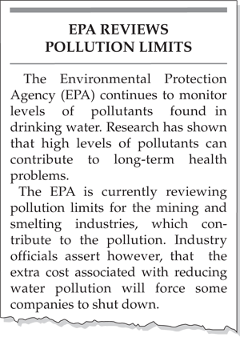
16. Which of these statements best supports the excerpt above?
- Government agencies have little interest in private industry.
- Government policy must balance health and economic concerns.
- The government should help fund mining and smelting industries.
J The government should allow industries to set their own environmental regulations.

Reflection: Justify why you chose your answer _____________________________________
__________________________________________________________________________
__________________________________________________________________________

Study the information below and then answer Questions 17 and 18.
Executive Order 9981 (1948)
“There shall be equality of treatment…for all persons in the armed forces…”

Executive Order 11141 (1964)
“[The government shall] assure that older people are not discriminated against because of their age…”

Executive Order 11246 (1965)
“The government…[will] provide equal opportunity in Federal employment for all qualified persons…”

17. What is the intent of each of these executive orders?

A to guarantee the safety of the people

B to maintain public order

C to protect the rights of individuals and groups

D to respect the constitutional rights of states

Reflection: Justify why you chose your answer _____________________________________
__________________________________________________________________________
__________________________________________________________________________

18. Which of these executive orders is most similar to the executive orders listed above?

F to guarantee the safety of the people

G to maintain public order

H to protect the rights of individuals and groups

J to respect the constitutional rights of states

Reflection: Justify why you chose your answer _____________________________________
__________________________________________________________________________
__________________________________________________________________________

DIRECTIONS: Examine the circle graphs below and then answer the question that follows.

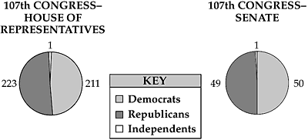
19. Based on the circle graphs, which of these statements is the most accurate?
A The Democratic Party has enough votes to amend the Constitution.
B The Republican Party has enough votes to override a Presidential veto.
C The Democratic and Republican parties must work together to pass legislation.
D The Democratic and Republican parties have enough votes to appoint a Supreme Court Justice.
Reflection: Justify why you chose your answer; what inferences can be made about the cartoonist? ____________________________________________________________________________________________________________________________________________________________________________________________________________________________________________________________________________________________________________________________________________________________

DIRECTIONS: Examine the information presented and then answer the select response question and constructed response question.

Apathy Among American Voters

The history of the Unites States is based on democracy. Democracy, in turn, is founded on the idea that supreme authority rests with the people, who express their opinions and desires primarily through voting. Low voter turnout in some recent elections seems to signal a state of apathy [a lack of interest] among voters. In addition, fewer and fewer citizens take part in such political activities as volunteering for campaigns.

Analyze the cartoon below, and then answer the questions that follow.
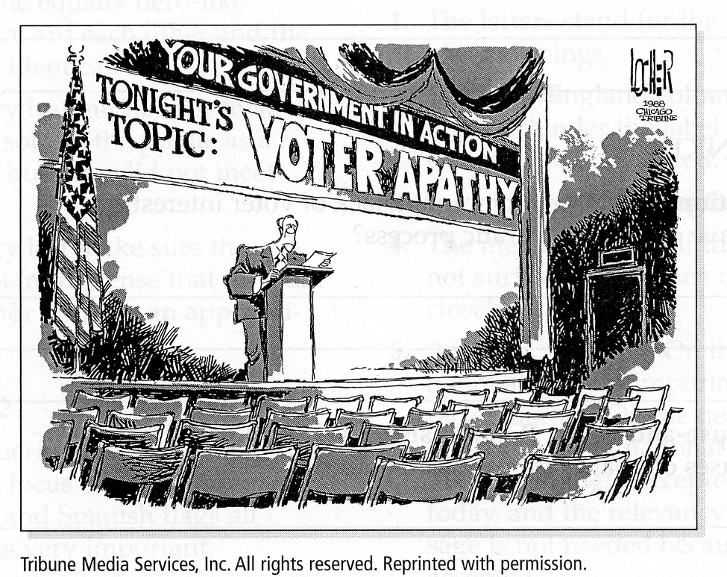

20. How does the cartoonist make his point about voter apathy?

F The decorations of the hall where the speech will be given

G The location of the speaker in the room

H The banner that reads “Voter Apathy”

J No one came to hear the speech

Reflection: Justify why you chose your answer; what do the cues from the cartoon say about the cartoonist’s point of view? {conservative/liberal, etc.} ________________________________
__________________________________________________________________________
__________________________________________________________________________

21. Which of these excerpts from the Constitution describes federalism?
A

B

C

D

Reflection: Justify why you chose your answer _____________________________________
__________________________________________________________________________
__________________________________________________________________________

Read the excerpt below and answer the question that follows.
“The right of citizens… to vote shall not be denied… on account of race, color or previous condition of servitude.”
—U.S. Constitution,
Amendment 15

22. Which of these principles of government is reflected in this amendment?
- judicial review
- federalism
- separation of powers
J popular sovereignty

Reflection: Justify why you chose your answer _____________________________________
__________________________________________________________________________
__________________________________________________________________________

Read the quotation below.

“…government of the people, by the people, for the people…”

–Abraham Lincoln, Gettysburg Address, 1863

23. Which type of government does Abraham Lincoln describe?

A democracy

B dictatorship

C monarchy

D oligarchy

Reflection: Justify why you chose your answer _____________________________________
__________________________________________________________________________
__________________________________________________________________________

24. The U.S. Constitution corrected a weakness of the Articles of Confederation by:

F establishing a national legislature

G allowing state governments to have power

H requiring that amendments be approved by the states

J giving the national government the power to collect taxes

Reflection: Justify why you chose your answer _____________________________________
__________________________________________________________________________
__________________________________________________________________________

25. The mass media is sometimes referred to as the “fourth branch of government” because it:

A endorses all government policies

B influences public opinion

C is a powerful federal agency

D is paid for with federal taxes

Reflection: Justify why you chose your answer _____________________________________
___________________________________________________________________________
___________________________________________________________________________

DIRECTIONS: Carefully read each stimulus and then fully complete the tasks given. Write your Constructed Response answer in the answer box provided on the next page.

CR A Read the quote below to answer the following question.

“Some lawmakers wish to censor music lyrics that encourage
violence and destructive behavior.”

What possible reasons could some lawmakers have in wanting to censor music?
- Based on what you know about the Bill of Rights, do you believe this type of censorship is constitutional? Explain why or why not.
- Include details and examples to support your answer.

CR A
_______________________________________________________________________________
_______________________________________________________________________________
_______________________________________________________________________________
_______________________________________________________________________________
_______________________________________________________________________________
_______________________________________________________________________________
_______________________________________________________________________________
_______________________________________________________________________________
_______________________________________________________________________________
_______________________________________________________________________________
_______________________________________________________________________________
_______________________________________________________________________________
_______________________________________________________________________________
_______________________________________________________________________________
_______________________________________________________________________________
_______________________________________________________________________________
_______________________________________________________________________________

Vocabulary Development Founding Documents

Creating Useful Study Aids to compare Founding Documents use with Chapter 2 of Textbook
Adapted from the Dinah Zike United States Government Reading and Study Skills

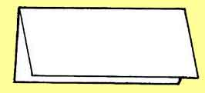
Step 1

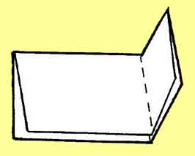
Step 2

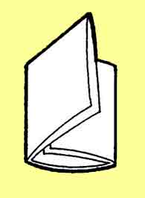
Step 3

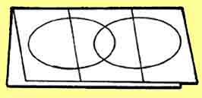
Step 4

Instructions for a Three-Tab Book Venn Diagram:

1. Fold a sheet of paper in half like a hotdog.
2. With the paper horizontal, fold the right edge toward the center, trying to cover one-half of the paper.
3. Fold the left side over the right and crease to form three tabs.
4. Draw two overlapping ovals on the front (see step 3) and use template provided. Write the word “Both” in the center of both ovals. On each oval write the following words:
Articles of Confederation
U.S. Constitution
5. Cut up the two valleys on one side only.

Inside the folded diagram, write out the major points for the Articles of Confederation and the U.S. Constitution (their differences). In the center, write out the similarities of the two documents.

Three-Tab Book Venn Diagram Template
Fold Here

Label Articles of Confederation
Cut Here

Label Both
Cut Here

Label U.S. Constitution

Vocabulary Development for Constitutional Freedoms

Creating Useful Study Aids to compare First Amendment Clauses use with Chapter 13 of Textbook
Adapted from the Dinah Zike United States Government Reading and Study Skills

Step 1

Step 2

Step 3

Step 4

Instructions for a Three-Tab Book Venn Diagram:

1. Fold a sheet of paper in half like a hot dog. Leave a 1-inch margin for labeling.
2. With the paper horizontal, fold the right edge toward the center, trying to cover one-half of the paper.
3. Fold the left side over the right and crease to form three tabs.
4. Draw two overlapping ovals on the front (see step 3) and use template provided. Write the word “Both” in the center of both ovals. On each oval write the following words:
The Establishment Clause
The Free Exercise Clause
5. Cut up the two valleys on one side only.

Inside the folded diagram, write out a brief definition of the establishment clause and list the ways it differs from the free exercise clause. On the right tab, do the same for free exercise clause. In the center oval, list ways both clauses protect freedom of religion.

Three-Tab Book Venn Diagram Template
Fold Here

Label Establishment Clause
Cut Here

Label Both
Cut Here

Label Free Exercise Clause

Congratulations!
You have now completed the LSN Winter Student Enrichment Packet!
You are well on your way to preparing for success in the
Local, State, and National Government Course!

