Algebra 2
Winter Student Enrichment Packet
Answer Key



Prince George’s County Public Schools
Office of Academic Programs
Department of Curriculum and Instruction

™

NOTE TO STUDENT

This Winter Student Enrichment Packet has been compiled to complement high school mathematics classroom instruction aligned to Maryland College and Career Ready Standards (MCCRS). It is intended to be used for review and practice of previously taught and new concepts.

We strongly encourage you to work diligently to complete the activities in this packet. You may experience some difficulty with some problems in this packet, but we encourage you to explore and attempt to find a solution to the best of your ability.




Lisa’s lifelong dream had been to open her own business. After working and sacrificing and saving, she finally had enough money to open up an ice cream business. The grand opening of her business is scheduled for the Friday of Memorial Day weekend. She would like to have a soft opening for her business on the Tuesday before. The soft opening should give her a good idea of any supply or personnel issues she has and give her time to correct them before the big official opening.

A soft opening means that the opening of the business is not officially announced; news of its opening is just spread by word of mouth (see, not all rumors are bad!). Lisa needs a good idea of when she should begin the rumor in order for it to spread reasonably well before her soft opening. She has been told that about 10% of the people who know about an event will actually attend it. Based on this assumption, if she wants to have about 50 people visit her store on the Tuesday of the soft opening, she will need 500 people to know about it.

Linda plans to tell one person each day and will ask that person to tell one other person each day through the day of the opening, and so on. Assume that each new person who hears about the soft opening is also asked to tell one other person each day through the day of the opening and that each one starts the process of telling their friends on the day after he or she first hears.

- Let x represent the day number and let y be the number of people who know about the soft opening on day x. Consider the day before Lisa told anyone to be Day 0, so that Lisa is the only person who knows about the opening on Day 0. Day 1 is the first day that Lisa told someone else about the opening.

Complete the table

Day | 0 | 1 | 2 | 3 | 4 | 5
# of people who know | 1 | 2 | 4 | 8 | 16 | 32

- After how many days will at least 500 people know about the soft opening?

Day | # of people who know
0 | 1
1 | 2
2 | 4
3 | 8
4 | 6
5 | 32
6 | 64
7 | 128
8 | 256
9 | 512
10 | 1,024
11 | 2,048
12 | 4,096
13 | 8,192

9 days before the opening.

- Write an equation that describes the relationship between x (day) and y (number of people who know) for the situation of spreading the news about the soft opening of Lisa’s ice cream store.
y = 2^{x}

Graph the equation.
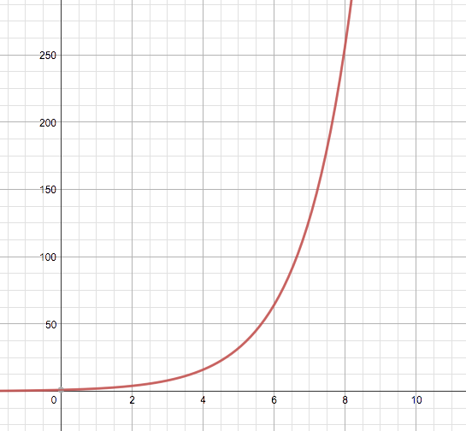
# of people who know
# of days

- Does your equation describe the relationship between day and number who know about Lisa’s ice cream store soft opening completely? Why or why not?
Answers may vary. Sample Response:
No, some people may not tell anyone of the soft opening.

- Let $f(x)=\frac{2x^{2}+7x−4}{x^{3}−1}$.

- What is the domain of $f(x)$?
{x| x ≠ 1}

- What is the range of $f(x)$?
All Real Numbers

- What are the roots of $f(x)$?
-4, 1/2

- Determine the end behavior of $f(x)$.

Answers may vary.

- Where will $f(x)$ intersect the y-axis?
(0, 4)
- Sketch the graph on the coordinate axis.



