Grade 5
Science
SPRING ENRICHMENT PACKET

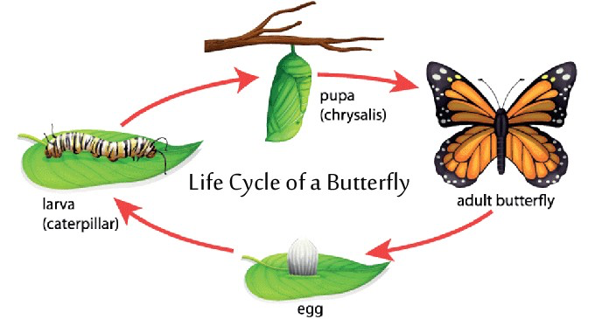



Prince George’s County Public Schools
Office of Academic Programs
Department of Curriculum and Instruction
Note to Student and Parents/Guardians

This is an “at-home” supplemental science instructional packet for middle school students during Spring Break.

This packet has been created to provide practice for students to answer Selected Response (SR) items and work through technical reading passages of informational text to write Constructed Responses (CRs) to support middle school science and the PGCPS Literacy Initiative. For Constructed Response items, it is highly recommended that students practice their annotating skills when reading the text.

Students will use the passages to write claims, evidence, and reasoning for Constructed Response items and circle the correct answer choice for Selected Response items.

- For more information about the PGCPS Literacy Initiative, visit: http://www.pgcps.org/literacy/ for parents and students.

The items in the Spring Enrichment Packet are aligned to the Next Generation Science Standards’ (NGSS) Science and Engineering Practices (SEPs).

For more information about the PGCPS Science and NGSS, visit:
- PGCPS Science Department: http://www1.pgcps.org/science/
- NGSS Website: https://www.nextgenscience.org/
- NGSS Parent Guide: https://tinyurl.com/NGSSParentGuide

The answer key for SR items and the writing rubric for CR items are located on pages 13 and 14.

A New Glue … from Inside Cow Bellies?
If you take a drive through the country, you might see a herd of cows munching on grass and shrubs. Unlike us, they can eat and digest tough, fibrous plants. They can do this, in part, because of bacteria that live in their bellies.
Those bacteria, like some that live in your own stomach, are very helpful. They feed on chewed-up food once it makes its way down into the cow’s gut. This helps grind the plant chunks into even smaller pieces so the cows can get the most nutrients from their food.
Paul Weimer studies these bacteria. He’s a microbiologist with the Agricultural Research Service in Madison, Wisconsin.
One day Dr. Weimer was watching some bacteria under a microscope. They were turning plant chunks into food for themselves and the cow in which they lived. He was impressed with how tightly the bacteria stuck to the plant material, and that gave him an interesting idea: “If the bacteria are so good at sticking to plant materials, wouldn’t they be good at sticking to other similar things, like wood? Could they be used to make a wood glue?”
Do you know why these little bacteria are so good at attaching themselves to things?
Dr. Weimer explains, “They have an outer slime layer that allows them to cling to a surface. In my laboratory, they stick so tightly to plant material, or cellulose, I can’t get them off without destroying them.”
Other bacteria are good clingers too. Some can stick to our teeth and cause cavities if we don’t brush them off. Eeeww!
It might sound really weird to you, but finding bacteria that can form a glue is a great discovery. It could help replace some of the smelly and expensive chemicals that are used right now to make wood products. That could help the environment.
- Based on Dr. Weimer's data, bacteria might be a good source for wood glue because the bacteria
_______________.

- are easy to grow
- stick tightly to each other
- stick tightly to plant materials
- can easily be taken from cow stomachs

2. Students measured the change in height of a plant during a 25-day period. The graph below shows their data.

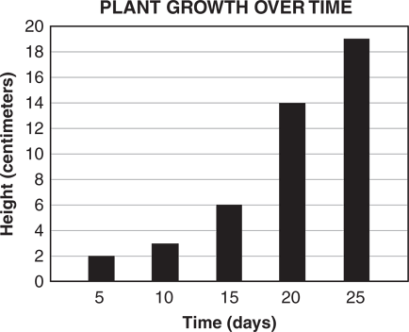

How many centimeters did the plant grow from Day 10 to Day 25?
- 3 centimeters
- 8 centimeters
- 16 centimeters
- 19 centimeters

3. Maryland air quality is reported daily using the color codes from the data table below.
AIR QUALITY
Color Code | Condition | Suggested Action
Green | Good | None
Yellow | Moderate | Very sensitive people should limit outdoor exercise.
Orange | Unhealthy for sensitive people | People with trouble breathing should limit being outdoors for long periods.
Red | Unhealthy | Everyone should limit outdoor exercise.

Which group of people would most likely be affected when the color code is yellow?

- adults who exercise regularly
- athletes in good physical shape
- teenagers who play soccer and football
- young children with breathing problems
Use the information below to answer Question 4.

Free Fall
Galileo first introduced the concept of free fall. His classic experiments led to the finding that all objects free fall at the same rate, regardless of their mass. According to legend, Galileo dropped balls of different mass from the Leaning Tower of Pisa to help support his ideas.
A freely falling body is an object that is moving under the influence of gravity only. These objects have a downward acceleration toward the center of the earth. Newton later took Galileo's ideas about mechanics and formalized them into his laws of motion.
Free-fall rides are really made up of three distinct parts: the ride to the top, the momentary suspension, and the downward plunge. In the first part of the ride, force is applied to the car to lift it to the top of the free-fall tower. The amount of force that must be applied depends on the mass of the car and its passengers. The force is applied by motors, and there is a built-in safety allowance for variations in the mass of the riders.
After a brief period in which the riders are suspended in the air, the car suddenly drops and begins to accelerate toward the ground under the influence of the earth's gravity. The plunge seems dramatic. Just as Galileo and Newton explain in their theories of free fall, the least massive and most massive riders fall to the earth with the same rate of acceleration. If the riders were allowed to hit the earth at that speed, coming to a sudden stop at the end of the ride, there would certainly be serious injuries. Ride designers account for this by building an exit track. The car is attached to this track, which gradually curves toward the ground. A stretch of straight track allows the car to slow down and brake, producing a controlled stop at the bottom, that keeps passengers from getting injured.
Two different-shaped objects were dropped from the same height. Data from the investigation was recorded, as shown below.
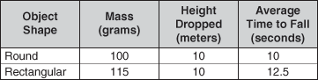

Free Fall
4. Explain why the average times to fall were different for the two objects. In your explanation, be sure to include
- the errors in this investigation
- how these errors affected the outcome
- how the investigation should be improved to obtain valid data
Write your answer in the space provided.

Use the information and the data list below to answer Question 5.
Two students researched how coal, a nonrenewable resource, is used. The students learned that most coal is burned to produce electricity. Some coal is used to make medicines, paint, and steel. The students recorded a list of some of the effects of burning coal.
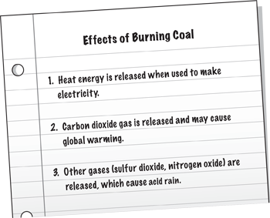
The students investigated how acid rain affected two plants of the same size. Plant 1 received pure water and Plant 2 received water containing acid. All other conditions were kept the same. After growing for five weeks, Plant 2 was shorter than Plant 1.
5. Which statement best explains the different results?
- Plant 1 received fertilizer.
- Plant 1 received direct sunlight.
- Water containing acid slowed the growth of Plant 2.
- Water containing acid decreased the size of Plant 2.

6. Students observed that fish in an aquarium opened and closed their gill slits faster on Thursday than on the previous Monday. Some students hypothesized that warmer water caused the change in gill slit movement. Other students hypothesized that dirtier water caused the change in gill slit movement.
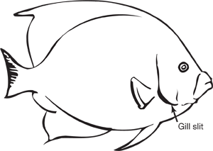
Both hypotheses are valuable because they _________________________________.
- are reasonable and testable
- compare independent variables
- are the only explanations possible
- link temperature with water quality

7. Seawater contains a number of different salts. The water can be separated by a process called distillation. A simple distillation setup is shown below.
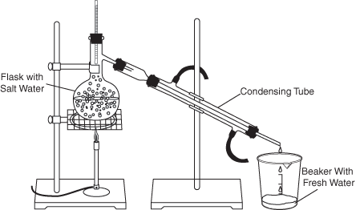
The water in the flask evaporates. Water vapor (gas) rises, leaving the salt in the flask. The water vapor is cooled in the condensing tube and drips into the beaker.
Why does salt remain in the flask?
- Salt is attracted to heat.
- Salt does not evaporate.
- Salt is too heavy to become a vapor (gas).
- Salt becomes water after it is heated.
Use the information below to answer Question 8.
Sunlight enters a room through an open window. The sunlight shines on the wood table, area rug on the floor, and the plane mirror and metal spoon on the table. A spot of light appears on the wall opposite the window.
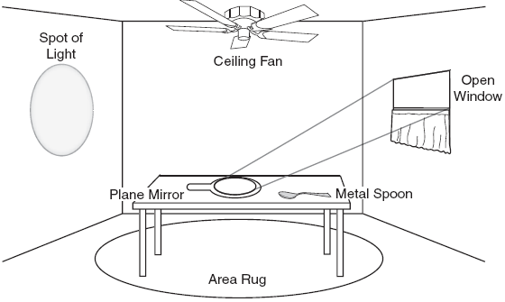

8. Which tool should be used to measure the length of the table?
- a balance
- a stopwatch
- a spring scale
- a centimeter ruler

Use the information below to answer Questions 9 and 10.
Making Fresh Water from Salt Water
Five students distilled equal masses of salt water in identical distillation devices. After several hours, the students measured a different amount of fresh water in each of the cups.
Although most water on Earth is salt water, humans can only live by drinking fresh water. Fresh water can be produced from salt water by separating the salt from the water. One method of separating salt from water is distillation. During distillation, salt water is heated until the liquid changes to a vapor, or gas. When the water turns to a vapor, the salt is left behind. When the vapor cools and changes to a liquid, it is fresh water.
The steps for making a simple distillation device are described below:
- Pour salt water in a bowl.
- Place an empty cup upright in the middle of the bowl of salt water.
- Cover the bowl and cup with plastic wrap.
- Place a small rock on the plastic wrap directly over the cup so the plastic wrap is pushed down slightly.
- Place the bowl in a sunny location.
The distillation device is pictured below:
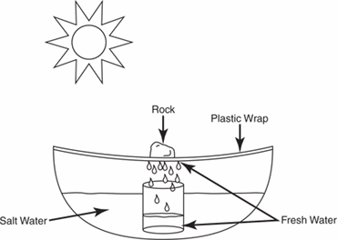
Sunlight causes water to evaporate. The vapor collects in droplets on the inside of the plastic wrap and rolls toward the lowest part of the plastic wrap, where the rock pushes it down. The droplets drip into the cup, filling it with fresh water. The salt stays in the bowl.

9. Which statement best explains this observation?
- The heat from the sun increased the flavor of the salt.
- The light from the sun turned some of the water into salt.
- The mass of salt increased to replace the lost water mass.
- The same amount of salt was present in a smaller volume of water.

A student repeated the distillation investigation but forgot to put the rock on the plastic wrap.
10. Describe the most likely result of this investigation. In your description, be sure to include
- the purpose of the rock
- how the results of this investigation compare with those of the original distillation
Write your answer in the space provided.
Use the information below to answer Question 11.
A Green Community
Many cities in the United States are developing “green communities.” A houses, apartments, and nearby businesses. Grocery stores, restaurants, and movie theaters are all within walking distance of the homes in the community. People travel shorter distances to their schools and jobs.
Many of the buildings in a green community are made of renewable and recycled materials. Solar energy keeps the buildings at a comfortable temperature. Natural landscape features, such as trees and plants, are carefully located to provide shade and to control temperatures. Community gardens allow residents to grow food and flowers.
11. People in green communities are using a nonrenewable resource when they
- heat their homes with wood
- wash vegetables before cooking
- drive gasoline-powered automobiles
- grow flowers in the community garden

12. A student is investigating which type of soil is best for growing tomato plants from seeds. The student plants four tomato seeds in each of three different containers of soil.
Which step of the procedure would help the student get the most reliable results?
- Place one container in a dark room.
- Use different types of tomato seeds.
- Change only the soil type in each container.
- Water each container with a different amount of water.

Answer Key

# Item | Answer
1 | C
2 | C
3 | D
4 | USE THE WRITING RUBRIC ON PAGE 14 TO SCORE
5 | C
6 | A
7 | B
8 | D
9 | D
10 | USE THE WRITING RUBRIC ON PAGE 14 TO SCORE
11 | C
12 | C

MISA 4-POINT RUBRIC
Rubric derived from the Maryland State Department of Education for use with Maryland Integrated Science Assessment (MISA).

Score Point 4
There is evidence in this response that the student has a full and complete understanding of the solution to a problem or constructs a full and complete explanation of the question.
- Demonstrates complete integration of the use of science and engineering practices such as modeling, engaging in argument from evidence, obtaining, evaluating, and communicating information, etc.
- Provides a solution or explanation that is coherent and based on disciplinary core ideas
- Reflects a complete synthesis of understanding of complex ideas and crosscutting concepts
- Includes an effective application of the 3 dimensions (SEP, DCI, and CCC) to a practical problem or real-world situation which demonstrates a complete understanding of the 3 dimensions
Score Point 3
There is evidence in this response that the student has a general understanding of the solution to a problem or constructs a complete explanation of the question.
- Demonstrates integration of the use of science and engineering practices such as, modeling, engaging in argument from evidence, obtaining, evaluating, and communicating information, etc.
- Provides a solution or explanation that is mostly coherent and based on disciplinary core ideas
- Reflects a synthesis of understanding of complex ideas and crosscutting concepts
- Includes an effective application of the 3 dimensions to a practical problem or real-world situation which demonstrates an understanding of the 3 dimensions

Score Point 2
There is evidence in this response that the student has a partial understanding of the solution to a problem or constructs an explanation of the question.
- Demonstrates some integration of the use of science and engineering practices such as, modeling, engaging in argument from evidence, obtaining, evaluating, and communicating information, etc.
- Provides a solution or explanation that is adequately coherent and based on disciplinary core ideas
- Reflects some synthesis of understanding of complex ideas and crosscutting concepts
- Includes an application of the 3 dimensions to a practical problem or real-world situation which demonstrates a partial understanding of the 3 dimensions

Score Point 1
There is evidence in this response that the student has a minimal understanding of the solution to a problem or constructs a minimal explanation of the question.
- Demonstrates little or no integration of the use of science and engineering practices such as, modeling, engaging in argument from evidence, obtaining, evaluating, and communicating information, etc.
- Provides a solution or explanation that is minimally based on disciplinary core ideas
- Reflects little or no synthesis of understanding of complex ideas and crosscutting concepts
- Includes an application of the 3 dimensions to a practical problem or real-world situation which demonstrates a minimal understanding of the 3 dimensions

Score Point 0
There is evidence that the student has no understanding of the solution to a problem or the question.
- The response is completely incorrect, too vague, or irrelevant to the solution or question

