SPRING STUDENT
ENRICHMENT PACKET
READING AND SOCIAL STUDIES
ANSWER KEY

Grade 4

™
Prince George’s County Public Schools
Office of Academics Programs
Department of Curriculum and Instruction

Hot off the press!
Spring Student Enrichment Packet!

You will notice Evidence-Based Selected Response (EBSR) questions in this year’s packet. EBSR questions are presented as a pair of related questions (Part A and Part B), where the second question asks students to select the evidence for the answer they chose in the first part of the question.

We have provided our students with many opportunities to practice answering Evidence-Based Selected Response questions, as we continue to prepare them for the Maryland Comprehensive Assessment Program (MCAP) assessments. With parents being our partners, we invite you to learn about EBSRs as you assist your children with completing the activities in this packet.

General Directions

Read the selection carefully so that you can do your best when answering the Evidence-Based Selected Response (EBSR).

Write your responses in this booklet, unless your teacher gives you other directions.

Circle the answer that is your choice.

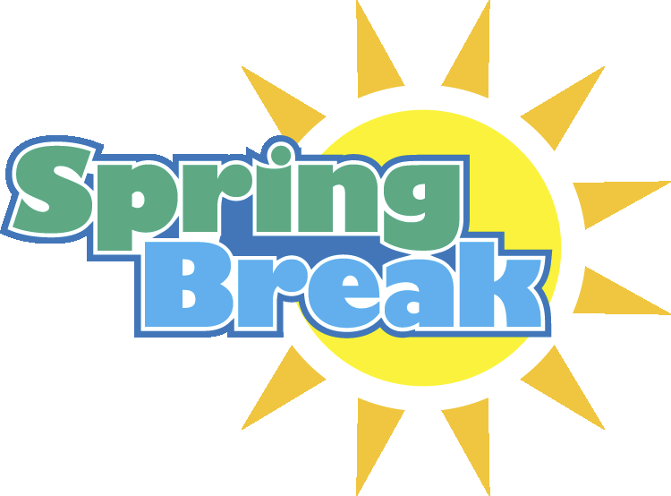
Have an enjoyable

That Kind of Day

1 It’s that kind of day
And that kind of season
When the breeze is sweet and the cool air calls
4 “Come out!”
It beckons the folks
who come out of doors
7 and wander about
pretending at first
to look for chores
10 although they know
they just want to walk
in the breeze and the pale
sunlight
14 it’s that kind of day

by Eloise Greenfield
from Under the Sunday Tree
HarperTrophy, 1991

- Part A
What do “the folks who come out of doors,” in lines 5 and 6, want to do?
- chores
- read
- hide
- walk
Part B
Which detail from the selection best supports your answer to Part A?
A. It’s that kind of day
B. Pretending at first to look for chores
C. Although they know they just want to walk in the breeze
D. It beckons the folk
2. Part A
What does the word “beckon” mean in line 5, when it says “It beckons the folk?”
- wanders
- pretends
C. walks
D. calls
Part B
Which line from the poem best supports your answer to Part A?
A. “When the breeze is sweet and the cool air calls ‘come out’”
B. “Who come out of doors and wander about”
C. “They just want to walk about”
D. “Pretending at first to look for chores”

3. Based on the poet’s choice of words, what season do you think is being described? Use evidence from the poem to support your decision.

________________________________________________________________
________________________________________________________________
________________________________________________________________
________________________________________________________________
________________________________________________________________
________________________________________________________________
________________________________________________________________
________________________________________________________________
________________________________________________________________
________________________________________________________________
________________________________________________________________
________________________________________________________________
_______________________________________________________________
_______________________________________________________________
_______________________________________________________________
______________________________________________________________
_______________________________________________________________
_______________________________________________________________
_______________________________________________________________
________________________________________________________________
_________________________________________________________________

Wild Hotels
By Deborah Churchman

• Most hotels are just places to stay. But some hotels are an extreme experience! Take a look at the ones on these pages.

On the Ice
This hotel is totally cool. It has to be--the whole thing is made out of ice! The Ice Hotel is in a village in Sweden, a country in Europe. You really have to go to the ends of the Earth to find it--it's north of the Arctic Circle! Most people get there by traveling on a sled pulled by dogs.

What's it like inside this giant igloo? It can be 60° F (15° C) warmer than the outside. But it's still below freezing in there. And just about everything--even the tables, chairs, and beds--is made out of ice. The hotel isn't heated (the ice would melt, duh), but it is wired for electricity. With the lights on, everything inside looks blue and sparkly. You can even watch movies in the Ice Cinema.
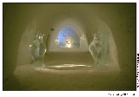
Ice Hotel

That Snice
Every year at the start of winter, people in the village build a new hotel. First, they spray wet snow onto huge metal arches. The snow freezes into something called "snice" and makes an icy frame. Then they cut huge blocks of ice from a nearby frozen river. They carve and shape this clear ice and combine it with the snice to make a giant igloo with dozens of rooms. Finally, they add carved ice pieces--ice "trees," ice columns, ice chairs, and even an ice chandelier.

The hotel lasts for the whole winter. But in spring, it turns into a big puddle.

Staying Overnight
What's it like to sleep in the ice hotel? A little chilly. The ice beds are covered with reindeer skin to keep out the cold. And the guests get special sleeping bags that keep them warm even in super-cold weather.

In the morning, guests get a hot drink of berry juice. Then they can jump into the hotel's hot tub. By then, they're all warmed up for a day of snowmobiling or dogsledding or maybe even learning how to drive a reindeer sled.

Isn't that snice? Er, nice?

Under the Sea
Go Deeper
Want to stay at the Jules Undersea Lodge in Florida? The first thing you have to do is learn how to scuba dive. The front "door" is 21 feet (6 m) underwater! (If you can't scuba dive, the hotel will teach you how.)
The lodge used to be an underwater lab for scientists who study marine life. They could sleep inside and then go right back into the water.
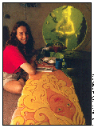Underwater Hotel

But not just scientists stay here now. Anyone who has ever dreamed of spending the night underwater can be a guest (if they have enough money). The lodge has hot showers, a microwave, and a television. Guests can even order pizza--delivered underwater!

In the Trees
Up High
Did you ever dream of having a tree house big enough to sleep in? How about 18 tree houses? That's how many there are at a hotel called the Out 'n' About Treesort in Oregon.

This hotel puts you high above it all--up to 37 feet (11 m) high in some of the houses. Steep steps lead up to each tree house.

The houses have solid, hardwood floors. They have lots of windows and skylights, too, so visitors get the feel of being right up in the trees. Most people love it. But if you're nervous about heights, this might not be the best place for you.

The hotel also has a ropes course to learn how to climb, a "tree institute" to study life in the trees, and classes in things such as tie-dyeing and mosaics. Down on the ground, you swim in a river-fed pool, go horseback-riding through the forest, or play with the local pets.

Near the tree houses, there's a hot tub for relaxing and a barbecue pit and kitchen for cooking. In late summer, there's a big patch of berries to pick. You can also go whitewater rafting nearby. But most of the fun is climbing the spiral stairs, swinging on ropes, and walking across the swaying bridges that take you to and from the different tree houses.

Visitors to the Out 'n' About Treesort say they have a (are you ready?) tree-mendous time.

Under the Ground
Down Under
A thousand years ago on the Great Plains, some Native Americans built earth lodges like this one. The big room inside was cool in the summer and warm in the winter. Today, you can visit and even stay in the same kind of earth lodge on Medicine Creek near Wellfleet, Nebraska.

The Dancing Leaf Earth Lodge started as a hole in the ground. Long poles made out of cottonwood trees were anchored around the edge of the hole. Willow branches were arranged on top in a cone shape and covered with a layer of dried prairie grass. Then the whole thing was covered with a thick layer of soil. A hole in the middle of the "ceiling" lets smoke go out and sunlight come in.

Visiting the lodge is like stepping into a whole other way of life. While there, you can learn how native people made tools and pottery, tanned hides, and farmed. You can even learn native stories and songs. Just what you'd expect at such a "wild" hotel, right?

"Reprinted from the December 2003 issue of RANGER RICK Magazine, with the permission of the

publisher, the National Wildlife Federation. Copyright 2003 by the National Wildlife Federation."
4. Part A
What is “snice” made of?
A. blocks of river ice
B. carved ice
C. frozen wet snow
D. reindeer skin
Part B
Which detail from the selection best supports your answer to Part A?
A. “Then they cut huge blocks of ice from a nearby frozen river.”
B. “They add carved ice pieces.”
C. “First, they spray wet snow onto huge metal arches. The snow freezes into something called
‘snice’ and makes an icy frame.”
D. “The ice beds are covered with reindeer skin to keep out the cold.”

5. Part A
What do the classes described in the “In the Trees” section teach?
A. how to study life in trees, how to do tie-dyeing and mosaics, and climb rope
B. how to swing on ropes, walk across tree bridges, and go whitewater rafting
C. how to swim, learn horseback riding, and pet animals
D. how to barbeque, pick berries, and climb spiral stairs
Part B
Which detail from the selection best supports your answer to Part A?
A. “But most of the fun is climbing the spiral stairs, swinging on ropes, and walking across the
swaying bridges.”
B. “Down on the ground, you swim in a river-fed pool, go horseback-riding through the forest,
or play with the local pets.”
C. “In late summer, there's a big patch of berries to pick.”
D. “The hotel also has a ropes course to learn how to climb, a "tree institute" to study life in
the trees, and classes in things such as tie-dyeing and mosaics.”
6. Write the steps for building an Earth lodge in the chart below:

- a hole in the middle of the "ceiling" lets smoke go out and sunlight come in
- willow branches were arranged on top in a cone shape and covered with a layer of dried prairie grass
- long poles made out of cottonwood trees were anchored around the edge of the hole
- the whole thing was covered with a thick layer of soil
- the Dancing Leaf Earth Lodge started as a hole in the ground

Event  1 | the Dancing Leaf Earth Lodge started as a hole in the ground
Event  2 | long poles made out of cottonwood trees were anchored around the edge of the hole
Event  3 | willow branches were arranged on top in a cone shape and covered with a layer of dried prairie grass
Event  4 | the whole thing was covered with a thick layer of soil
Event  5 | a hole in the middle of the "ceiling" lets smoke go out and sunlight come in

7. The article “Wild Hotels” described four unusual places that people can visit, and even spend the
night. Choose one of the four hotels, and write an original story about your overnight stay there. In your story, be sure to use what you learned about the hotel as you write about your experience.
To create a well-written story remember to:
  - Write a beginning that gets the reader into the world of the story and helps then understand what is going on.
  - Use transition words to help readers understand what events happened.
  - Use details that describe exactly what happened in the story and how you were thinking and feeling.
  - Write an ending that connects to what the story is really about.

________________________________________________________________
________________________________________________________________
________________________________________________________________
________________________________________________________________
________________________________________________________________
________________________________________________________________
_________________________________________________________________
__________________________________________________________________
__________________________________________________________________
__________________________________________________________________
___________________________________________________________________
__________________________________________________________________
__________________________________________________________________
__________________________________________________________________
_________________________________________________________________
_________________________________________________________________
_________________________________________________________________

________________________________________________________________
________________________________________________________________
________________________________________________________________
________________________________________________________________
________________________________________________________________
________________________________________________________________
_________________________________________________________________
__________________________________________________________________
__________________________________________________________________
__________________________________________________________________
___________________________________________________________________
__________________________________________________________________
__________________________________________________________________
__________________________________________________________________
_________________________________________________________________
_________________________________________________________________
_________________________________________________________________
_________________________________________________________________
_________________________________________________________________
_________________________________________________________________
_________________________________________________________________
_________________________________________________________________
_________________________________________________________________

A Magical Pen
By Ruth Spencer Johnson
Cast:
Thomas Jefferson
His Grandchildren:
Ellen, Age 14
Virginia, Age 9
Mary, Age 7
James, Age 4
Narrator
Act One Scene One
(One evening at Monticello, Thomas Jefferson sits in the parlor as some of his grandchildren dance around him. Red curtains drape over the tops of tall windows. Portraits of famous people like Ben Franklin and John Adams cover the walls. The floor is parquet--pieces of wood that fit together to make a pattern.)
Narrator: After two terms as president of the United States, Thomas Jefferson has retired to Monticello. Here in the parlor, Thomas loves to play games and music with his daughter Martha's children.
(Jefferson's young granddaughter Mary climbs onto his lap.)
Mary: Grandpapa, please tell us the story of how you wrote the Declaration of Independence!
Narrator: Remember, during the American Revolution, the Continental Congress met in Philadelphia and decided that the 13 American Colonies should separate from England. The Declaration of Independence is the famous document stating why America should be a free and independent country.
Jefferson: Why, you children have heard me tell that story many times!
Ellen: I never get tired of hearing it, Grandpapa.
Jefferson: Well, all right. (Ellen, Virginia, and James sit on the floor in front of Jefferson.) On June 11, 1776, the Continental Congress put me on a committee of five people to write the Declaration. The committee met, and we talked over ideas for the document.
Virginia: (pointing to the portraits) Ben Franklin and John Adams were on the committee, too.
Jefferson: The committee asked me to write a rough draft of the Declaration. I was one of the youngest members of Congress, only 33, but I said I would do my best.
James: Why did the committee choose you?
Jefferson: They said I was the best writer--that I had a "masterly pen."
Mary: John Adams said you could write 10 times better than he could!
Narrator: Over the next 17 days, Jefferson worked on the Declaration whenever he wasn't busy in Congress. He wrote the document on a portable writing desk he had designed himself.
Ellen: How did you decide what to write?
Jefferson: I believed with all my heart that America should be a free nation. I tried to make that idea so plain and clear that anyone reading the Declaration would have to agree.
Virginia: You wrote that all men are born free and equal. And people have the right to control their own lives.
Ellen: You listed the Colonies' complaints against England and explained why Americans wanted independence.
Jefferson: I hoped to inspire my countrymen with my words, but I had to work quickly. Congress was in a hurry to get the document.
James: What happened next?
Jefferson: I showed my rough draft to the committee, and they made a few changes. Overall, I think they were pleased with my work.
Narrator: Jefferson presented the Declaration to Congress. On July 2, Congress voted for independence from England. Then the delegates began to go over the Declaration, line by line.
Mary: The delegates thought your writing was beautiful, didn't they?
Jefferson: Well, they certainly argued about it--for almost three days! They changed words and cut out some parts, but most of the wording was still my own.
Virginia: Did the changes hurt your feelings, Grandpapa?
Jefferson: It was painful to listen as the delegates criticized the document I had worked so hard on.
Narrator: On July 4, Congress approved the final version of the Declaration. That's why we celebrate America's birthday on the fourth of July.
Ellen: You should be proud--the Declaration of Independence inspired people to fight for freedom.
Virginia: With your pen, you took ordinary words and turned them into something special--almost like magic!
James: Grandpapa, you must have a magical pen!
(Everyone laughs.)
Jefferson: Now children, let's light the candles and find a book to read. You know I just can't live without books!

APPLESEEDS (Vol. 8, No. 7) March 2006, pp. 12-15 Copyright © Cobblestone Publishing Company. March 2006. All rights reserved. Reprinted with permission.
********************************************************************************************************

8. Choose the main idea of the play “A Magical Pen” and write in the box labeled “Main Idea.” Choose 2 details from the play that best support the main idea and write them in the empty box labeled “Supporting Detail(s).”

Response to 8:

Possible Main Ideas
John Adams said Thomas Jefferson could write 10 times better than he could.
On July 4, Congress approved the final version of the Declaration.
On July 2, Congress voted for independence from England.
Thomas Jefferson believed with all his heart that America should be a free nation.
The delegates thought Thomas Jefferson’s writing was beautiful.
Possible Supporting Details
“Thomas Jefferson had a magical pen!”
“The Declaration of Independence inspired people to fight for freedom.”
“Thomas Jefferson hoped to inspire his countrymen with his words.”
“The delegates began to go over the Declaration, line by line.”
“Thomas Jefferson wrote that all men are born free and equal. And people have the right to control their own lives.”
“We celebrate America's birthday on the fourth of July.”

Main Idea 1

Supporting Detail

Supporting Detail

The Wild Ponies of Assateague Island

Directions: Read the two articles below. Then answer the questions that follow.
VOCABULARY

Vegetation: plant life
Secluded: private, away from others
Solitude: being alone
Extensive: being wide or large
Ecosystem: a system of living things interacting with their environment

Wild Ponies
Most ponies you see live on farms or ranches. Others work in carnivals or sometime pull carriages in cities. But the ponies in this article live in the wild!
These ponies run free on an island just off the Atlantic coast of Maryland and Virginia called Assateague (ass-uh-teeg). They live together in small groups called bands. Each band consists of two to twelve ponies.
The ponies eat leaves, twigs, and grasses. From spring to fall, there is a lot to eat on the island. However, the island can be a hard place to live. In winter, it gets very cold, and there is less vegetation.
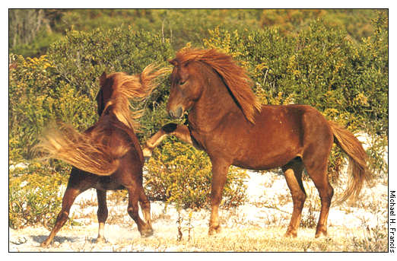
Stallion ponies fighting
In summer, there are many biting insects. The ponies like to stand on the beach and let the wind blow away some of the insects.
Every pony band has one adult male called a stallion. That stallion protects his band. Sometimes stallions get into fights over who is in charge of a band. They will kick each other until one of them gives up and goes away.
Pony moms are called mares. Mares have their babies in the spring.
The babies are called foals. Foals know how to walk just a few minutes after they are born. They drink milk from their mothers to grow bigger. Later they start eating grass like the other ponies.


When you are on Assateague Explorer's Pony Express Nature Tour, you visit the areas where you have the greatest chance of seeing wild ponies on your vacation. You will explore many secluded areas of Assateague Island's wildlife refuge where wild ponies live. Assateague Ponies are a unique breed and have lived here in solitude for about 400 years. Different bands, or herds, are dispersed along this extensive island. Our native captain knows where to travel to see many herds along the island each day. You will encounter a large variety of birds, wildlife and sometimes dolphins along the way. We see bald eagles in these areas almost every day.
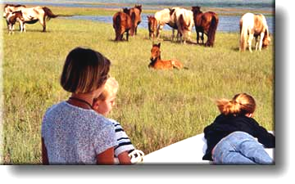
Over 300 wild ponies live on over 40,000 acres of Assateague Island, and it is estimated that less than three percent of these wild ponies can be seen from the road by visitors on vacation. Assateague Island is an unspoiled vast ecosystem of forests, wetlands, beaches and calm waterways. Assateague has only one street and the U.S. Fish and Wildlife Service has placed miles of fence along it to keep the wild ponies far back in their natural habitat. These pony-watching trips will take you to Assateague's most beautiful areas where over 150 wild ponies live.
Tourists at Assateague Island

Reading selections adapted from
“Wild Ponies”
Your Big Backyard Magazine
(August 2004)
SIRS Discoverer
and
“Assateague Explorer Tours”
http://www.assateagueisland.com/ponyexpress_tour.htm

9. Part A
Read the sentence from the article. What does the word vegetation mean as used in
this sentence?
“The ponies eat leaves, twigs, and grasses. From spring to fall, there is a lot to eat on the island. However, on the island can be a hard place to live. In the winter, it gets very cold, and there is less vegetation.”
  - sun
  - heat
  - plants
  - water
Part B
Which phrase from the sentences helps you understand the meaning of vegetation?
- eat leaves, twigs, and grasses
- a lot to eat on the island
- a hard place to live
- it gets very cold

10. You have read two articles about wild ponies that live on an island call Assateague.
Write an essay to explain the lifestyle of wild ponies and how living on the island helps to protect them for over 400 years.
To create a well written essay, remember to include:
  - an interesting introduction to grab the reader’s attention
  - paragraphs with main ideas and supporting details
  - facts as evidence from the articles
  - a closing

________________________________________________________________
________________________________________________________________
________________________________________________________________
________________________________________________________________
________________________________________________________________
________________________________________________________________
________________________________________________________________
________________________________________________________________
________________________________________________________________
________________________________________________________________
________________________________________________________________
________________________________________________________________
________________________________________________________________
________________________________________________________________
________________________________________________________________
________________________________________________________________

________________________________________________________________
________________________________________________________________
________________________________________________________________
________________________________________________________________
________________________________________________________________
________________________________________________________________
________________________________________________________________
________________________________________________________________
________________________________________________________________
________________________________________________________________
________________________________________________________________
________________________________________________________________
________________________________________________________________
________________________________________________________________
________________________________________________________________
________________________________________________________________
________________________________________________________________
________________________________________________________________
________________________________________________________________
________________________________________________________________
________________________________________________________________
________________________________________________________________
________________________________________________________________

________________________________________________________________
________________________________________________________________
________________________________________________________________
________________________________________________________________
________________________________________________________________
________________________________________________________________
________________________________________________________________
________________________________________________________________
________________________________________________________________
________________________________________________________________
________________________________________________________________
________________________________________________________________
________________________________________________________________
________________________________________________________________
________________________________________________________________
________________________________________________________________
________________________________________________________________
________________________________________________________________
________________________________________________________________
________________________________________________________________
________________________________________________________________
________________________________________________________________
________________________________________________________________

Reading Log for Spring Break Grade 4
Read for a minimum of 15 minutes for each day of Spring Break. Please record what you read below. Read books from home or your public library.

Date | Title | Author | Pages Read | Minutes Read

