Algebra I Common Core
SPRING STUDENT
ENRICHMENT PACKET
Answer Key



™

Prince George’s County Public Schools
Office of Academic Programs
Department of Curriculum and Instruction

F-IF.7a-1
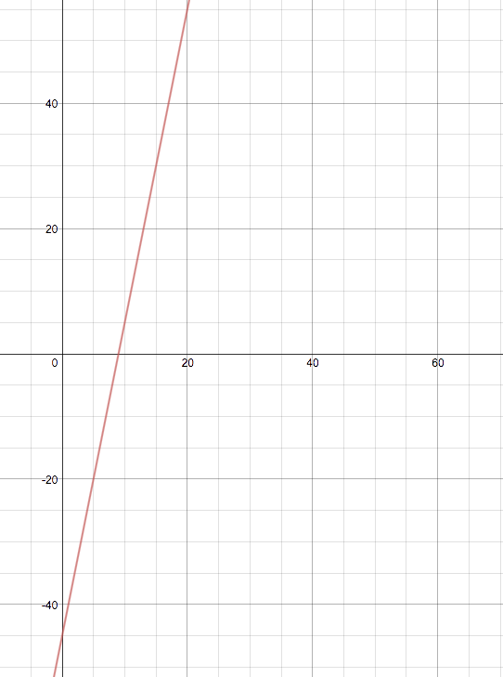

(0, -45)
(9, 0)

A.CED.4-1

$$h=−\frac{1}{2g}v^{2}+\text{165}$$

A.REI.4b-1

A and B
A.REI.10
F.LE.2-2

x | f(x)
2 | 5
4 | 7
5 | 8
11 | 14

y = x + 3
A.REI.12

C
F.BF.3-1

-3
F.BF.3-1

C
S.ID.2

- C
- B
- A
S.ID.3
- The age range of female users is greater than the age range of male users.

- The percentage of female users that are ages 10 - 15 is greater than the percentage of male users that are ages 10 – 15.

- The median age of female users is greater than the median age of male users.

- There is a 30 year age difference between the oldest female user and the oldest male user.

A.SSE.1

A
A.REI.12

D
A.REI.4a-1

-3

42
A.APR.1-1

45

-83

-12

56
F.LE.2-1

C
F.IF.4-1

D
F.IF.4-1

B
F.IF.5-1

D
F.IF.6-1b

C
F.IF.6-6b

D
F.IF.9-1

B

F.IF.1

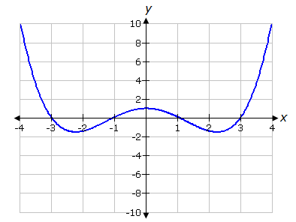

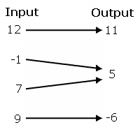

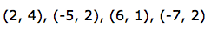
F.IF.2

D
F.IF.7a-1

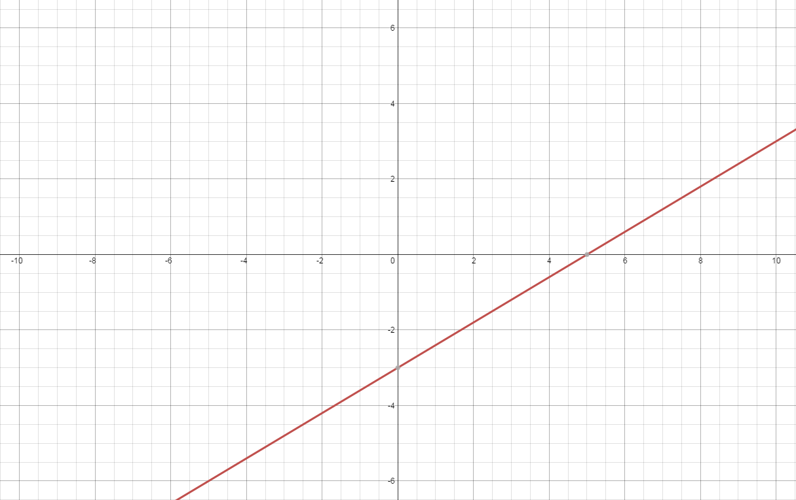
A.CED.4-2

B
A.SSE.1-2

C

